**Calculus AB Notebook**

William Callan



There’s lots of very fascinating math behind the Rubik’s Cube despite its small size. The standard cube has over 43 quintillion possible combinations, but each one can be solved in 20 moves or less, also known as God’s Number. God’s Number for 3x3 has been proven to be 20 through computer algorithms but the number for higher cubes is yet unproven, so even 40 years since its invention the cube still hasn’t *fully* been cracked. Currently this number can be approximated with the formula $\frac{n^{2}}{\log{n}}$ for any n x n x n Rubik’s Cube, but no definitive answers have been found beyond the 2x2 and 3x3 cube. Rubik’s cube solving has also turned into a competitive hobby, with over 100,000 competitors competing across the world in regular competitions and the official world record standing at 3.47 seconds

Title Page

Table of contents

**Limits**

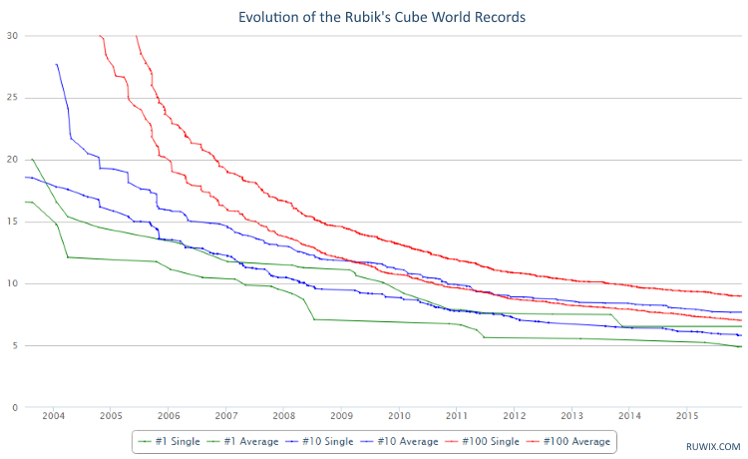

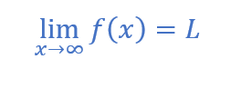

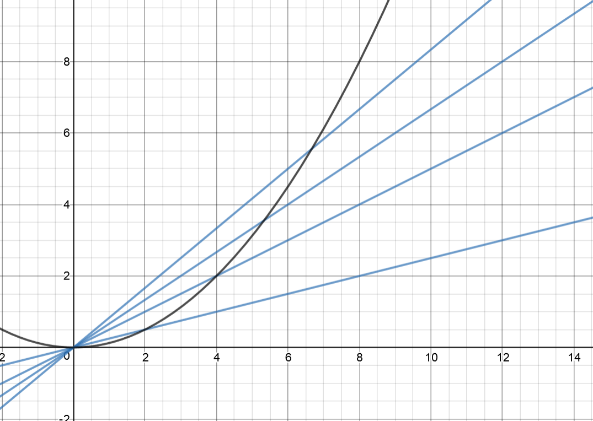

**Included Topics:**

* What is a limit?
* Methods of evaluation
* When do limits fail to exist?
* What is a one-sided limit?
* What is a general limit?
* Limits at infinity vs. infinite limits
* Tricky trig limit formulas

**Continuity**

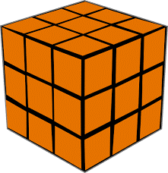

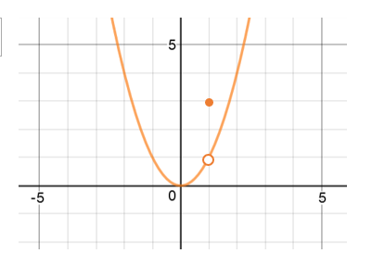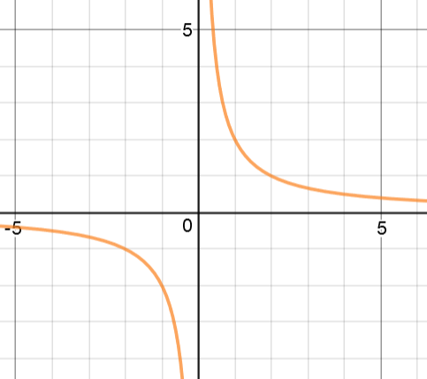

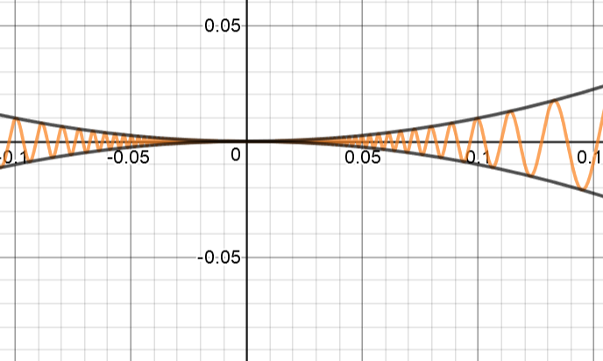

**Included Topics:**

* What is continuity?
* 3 types of continuity
* What is a discontinuity?
* The squeeze theorem
* Intermediate Value Theorem?

**The Derivative**

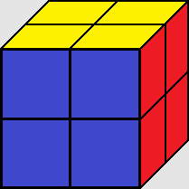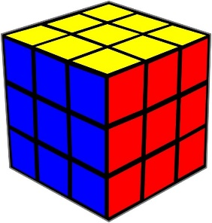

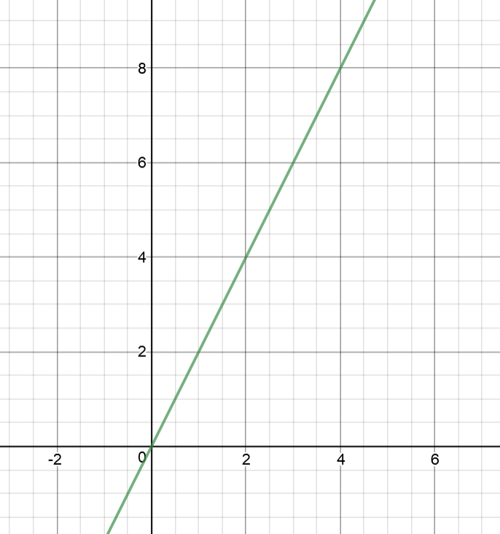

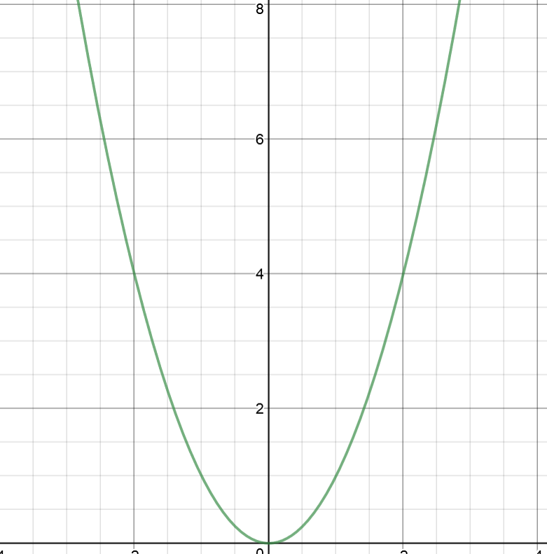

**Included Topics:**

* What’s the point?
* General limit definition
* When is a function not differentiable?

**Basic Differentiation Formulas**

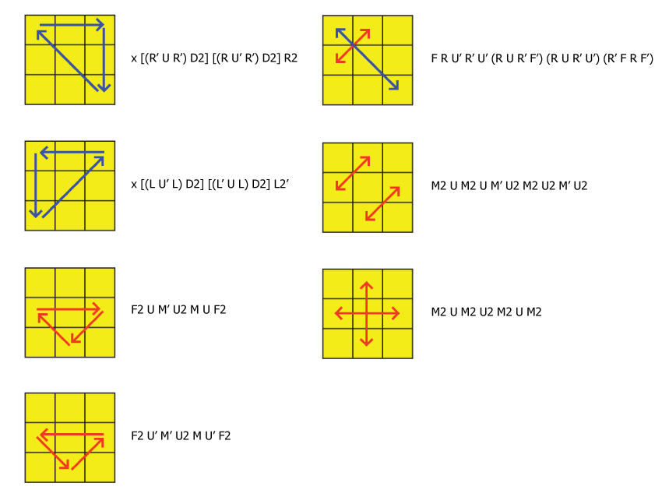

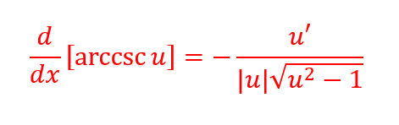

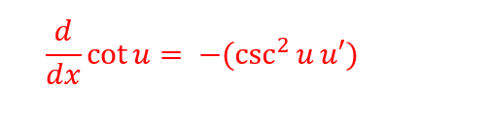

**Included Topics:**

* Steps for implicit differentiation

**Applications of the Derivative**

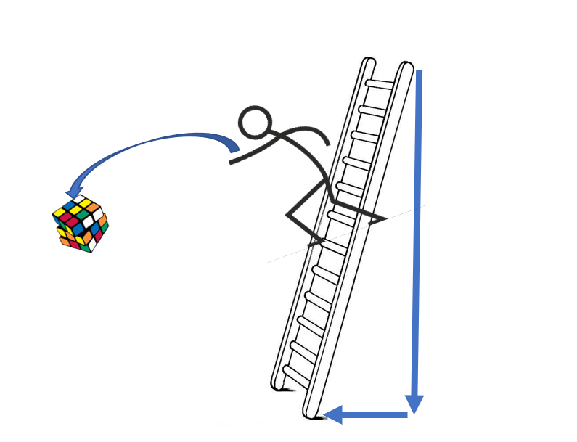



**Included Topics:**

* Extreme value theorem
* Mean value theorem
* Important terms
* The first derivative test
* The second derivative test
* Position, velocity, and acceleration
* Related rates problems
* Optimization problems

**The Integral**

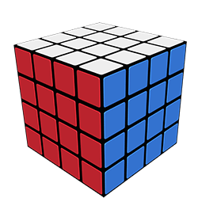Original Derivative

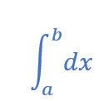

**Included Topics:**

* What’s the point?
* Indefinite vs definite integrals
* The fundamental theorem of calculus
* The second fundamental theorem of calculus
* Average Value

**Basic Integration Formulas**

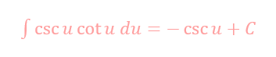

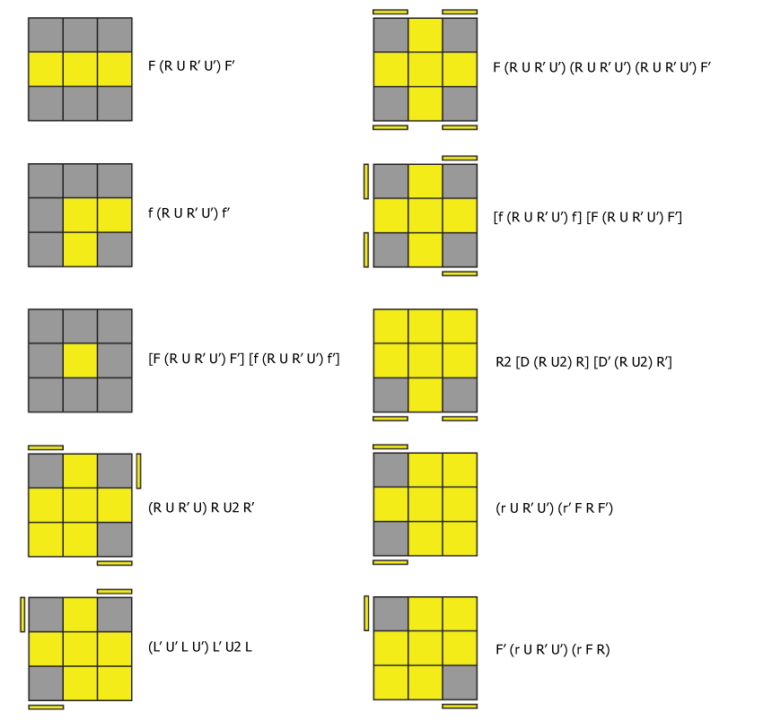

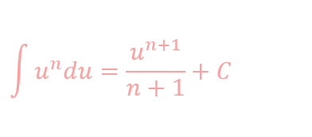

**Included Topics:**

* U Substitution
* Numerical integration
  + LRAM, RRAM, MRAM
  + Trapezoid Rule

**Applications of Integration**

* + **Included Topics:**
* U Substitution
* Numerical integration
  + LRAM, RRAM, MRAM
  + Trapezoid Rule